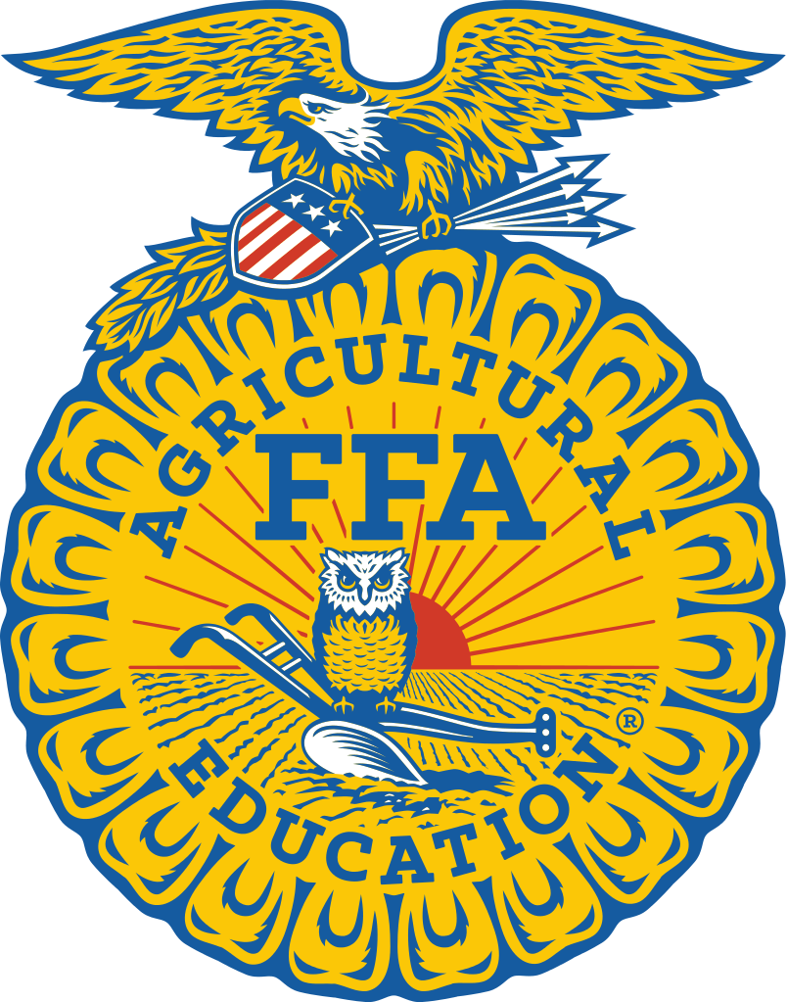
Delaware FFA Association State Officer Application

Application will be due electronically submitted to Sarah.Bell@doe.k12.de.us by February 5th, 2026. Be sure that you are completing this application to the best of your ability and attaching the required documents with this application. Please read through the Delaware FFA State Officer Handbook before completing the application. Additional questions should be directed to State FFA Advisor Mrs. Sarah Bell.

NAME DATE OF BIRTH
CHAPTER GRADE GRADUATION DATE
MEMBER ID YEARS IN AGRISCIENCE
ADDRESS
CITY STATE ZIP
PHONE EMAIL

Candidates Leadership and Activities
A.jList all FFA Offices held:
OFFICE | LEVEL | YEAR(S)

B. List All FFA Leadership Activities Attended:
ACTIVITY | YEAR(S)

C. List All FFA Career/ Leadership Development Events/ Participated In:
CDE/LDE | YEAR(S) | LEVEL ACHIEVED (STATE, LOCAL, NATIONAL)

D. List All FFA Awards and Recognition:
ACTIVITY | YEAR(S)

E. List Any School or Community Activities Other Than FFA:
ACTIVITY | YEAR(S)

Candidate Essay Responses
In the space below or on a separate sheet of paper that will need to be attached to this application, please answer the essay response question below. There is a 500-word limit.

What do you want to accomplish as a Delaware FFA State Officer?

Candidate Video Prompt
Each candidate is required to submit a 1–2-minute introductory video which will be played to the Delaware Nominating Committee and be their first introduction to you as a State Officer Candidate. There should be no graphic effects, splicing of audio, or additional visual effects. The video may be taken in different locations and the audio may be increased if it is hard to hear. Use the questions below as guidance to creating your video:

Who are you? What is your background? How has FFA made a positive impact on your life?

Upload your video to Google Drive and share with Caitlin.Rozell@delaware.gov .

Required Signatures
Candidate Statement: I hereby submit this application packet for State Office in the Delaware FFA Association. The information included in this application is correct to the best of my knowledge.

Candidate Signature: _________________________________________ Date: _________

Parent/Guardian’s Statement: I am willing for my child to be a State Officer in the Delaware FFA Association, and should they be elected to this honor, I will cooperate with them and the Delaware FFA Association in fulfilling the duties of the office. I realize that my child will be away from home and from school several days and nights during the year.

Guardians Signature: _________________________________________Date: _________

*NOTE: At least 50% of the FFA Advisors in the nominees Agriscience Department must sign areas requiring Advisor signatures If an Advisor does not recommend the application

FFA Advisor’s Signature: I do/ do not recommend that this candidate be considered for State Office in the Delaware FFA. They are/ are not a member in good standing and has / has not been active in the chapter. I have examined the application and found it to be / not to be correct.

Signature: ____________________________________________________ Date: _________

FFA Advisor’s Signature: I do/ do not recommend that this candidate be considered for State Office in the Delaware FFA. They are/ are not a member in good standing and has / has not been active in the chapter. I have examined the application and found it to be / not to be correct.

Signature: ____________________________________________________ Date: _________

FFA Advisor’s Signature: I do/ do not recommend that this candidate be considered for State Office in the Delaware FFA. They are/ are not a member in good standing and has / has not been active in the chapter. I have examined the application and found it to be / not to be correct.

Signature: ____________________________________________________ Date: _________

FFA Advisor’s Signature: I do/ do not recommend that this candidate be considered for State Office in the Delaware FFA. They are/ are not a member in good standing and has / has not been active in the chapter. I have examined the application and found it to be / not to be correct.

Signature: ____________________________________________________ Date: _________
FFA Advisor Reference
Candidate Name________________________________.
FFA Chapter__________________________
Advisor Name___________________________________
WHO MAY COMPLETE THIS FORM: An agriscience teacher who has had the candidate in class or as an advisor. The candidate need not be studying with the reference presently; however, the student should carefully choose someone who can best answer all questions on the form.

Part 1:
For each item below, assess the candidate by assigning one of the values.
A= Exceptional B= Above Average C=Average D=Below Average E= Not observed

____ Analytical Ability
____ Initiative and Independence
____ Written Communication Skills
____ Oral Expression
____ Interaction with Others
Part 2:
How does the candidate compare in overall promise with other students you have known in the past 3 years?

____ Among the very best I have known
____ Very good, but not the very best
____ Average
____ Below Average

Part 3:
Please write a one page, one sided letter of recommendation including the following information about this applicant's strengths and weaknesses, explaining why you rated the applicant as you did in Part 1 and 2. Please cite examples of outstanding contributions or challenges. Your response will assist the committee in understanding if this candidate is ready for a sustained, intensive, leadership experience.

State FFA Officer Commitment Form

- Be dedicated and committed to the FFA and the total program of education.
- Be willing to commit the entire year to state office activities.
- Be willing and able to travel in serving the Delaware FFA
- Become knowledgeable of agriculture, education in agriscience, and of FFA.
- Through preparation and practice, develop me into an effective public speaker and project a desirable image.
- Regularly write letters, thank you notes and other correspondence.
- Strive to improve my ability to carry on meaningful conversations with individuals of all ages and walks of life.
- Accept and seek out constructive criticism of my total performance.
- Keep myself up to date on current events.
- Maintain and protect my health and report illness, injuries, or problems to a state staff member so that action can be taken.
- Forego all alcohol, tobacco, and illegal substances while serving as a state officer.
- Treat all FFA members equally by not favoring one over another.
- Conduct myself in a manner which commands respect without display of superiority.
- Avoid places of activities that in any way would raise questions.
- Consider FFA officer activities to be my primary responsibility.
- If enrolled in college, maintain a GPA of at least 2.0 and not fail any classes.
- Use wholesome and appropriate language in all conversations.
- Maintain proper dress and good hygiene to project a desirable image of FFA.
- Work in harmony with fellow FFA Officers.
- Serve as a member of the team, have a cooperative attitude and supporting the decision made by the officer team, even if I do not agree with them.
- Agree not to initiate or pursue inappropriate personal relationships with officers from other states or chapter officers/members from within our state; or initiate personal relationships with other members of the State Officer Team.
- Agree not to post inappropriate pictures or text on websites, social media, or electronic communications. Maintain a professional image on social media. My relationship status will remain single on private social media during my term as a state officer. (E.g. Snapchat, Facebook, Instagram, TikTok)
- State FFA Officers are required to maintain a permanent residence in Delaware.
- Be willing to take and follow instructions as directed by those responsible for FFA Officers and state and national programs.
- Seek to improve the Association and its members by creating new opportunities and activities for students to become involved.
- When traveling to Conventions, Conferences, or CDE/LDEs
  - Keep the room assignment given to me.
  - Be in my room by curfew.
  - Participate in all programs and demonstrate appropriate behavior.
  - Not allow members of the opposite sec in my hotel room unless authorized.
- Attendance Policy
  - If I miss one meeting, I shall be notified by State Staff that I have missed the meeting. After two misses, I will be dropped from office, unless I present valid explanation for missing the meeting.
  - Valid explanations must be submitted to state staff after the meeting.
  - Special situations can be presented to State Staff for consideration.
  - Attendance at all meeting and functions is mandatory with arrival time being 15 minutes prior to the beginning of the function.
  - Communication is the key to success of the state office team.
- Be Available to participate in the following activities during the year.
  - State Officer trainings:
    - Base camp, Check Points, State Officer Summit
  - State FFA Officer team and board meetings.
  - Conferences
    - COLT
    - Discovery Conference
    - Vision Conference
  - Chapter Banquets and Visits
  - State FFA CDE/LDE events.
  - Delaware State Fair
  - National FFA Convention
  - State Convention Planning and State Convention
  - Big E
  - Team Ag Ed Meetings
  - Delaware FFA Foundation Fundraising Events
  - Statewide member Activities
    - Ice Skating
    - FFA Week

I have read, studied, and understood the commitment form. If elected, I will carry out my responsibilities in accordance with these statements and understand that I can be removed from office if I do not satisfactorily follow these established standards. I understand that if I am removed from office for any of the above reasons, I can appeal to Delaware Team Ag Ed and the State FFA Officers. I also understand that if I am ever removed from office because of a violation, I will be prohibited from seeking state office in the future.

Candidate Signature: _______________________________________ Date: __________
Guardians Signature: ________________________________________ Date: __________
Delaware FFA State Officer Application Checklist
Look over this list to ensure you have everything prepared to submit for your officer application:
- Read through Delaware FFA State Officer Handbook
- State Officer Application fully completed (typed preferably)
- Response to Essay Question Attached
- High school/ College Transcript (may be unofficial)
- Advisor Signature(s)
- FFA Advisor Reference and Letter of Recommendation
- SOC Video Submitted
- State Officer Commitment Form Signed
- Qualifies for/Received State Degree
  - All applicants must qualify for state degree or have received it previously. Complete the state degree application on the AET if you have not received the degree. If you have a State Degree already, there is no additional requirement.

